**Introduction**

A laser (Light Amplification by Stimulated Emission of Radiation) is a light source generated by the induced emission of radiation. The laser medium consists of a material which electron level structure is such that allows the input of energy (pumping) into the system to create a population inversion between the laser level and a lower energy level. For this a four state or three level system is required, in which the pumping excites the electrons from the lowermost level into the upper and the electrons then decay rapidly to the upper laser level. The lasing (radiation of coherent light through stimulated emission) occurs when photons of the frequency corresponding to the energy gap between the upper and lower laser levels causes stimulated emission in the excited atoms. Each stimulated emission event generates and extra photon with the same energy and phase as the original one. This process causes an amplification of light of the laser frequency that can be sustained if the pump provides energy to the system at sufficient rate to restore atoms to their excited state. For the experiment, a Nd:YLF crystal (Neodimium ions embedded in Yttriumlithiumuoride) is used as a laser medium.

The laser medium is placed inside a laser cavity or resonator, which consist of an

optical cavity between two mirrors, so that light traveling inside it in the direction of the optical axis repeatedly passes through the gain medium and gets amplified. One of the two mirrors is an imperfect reflector so that it lets a small fraction of the incident light pass through, which creates the laser beam. The distance between the mirrors imposes the allowed longitudinal modes of the cavity. Since the width of the wavelength span for which the stimulated emissions occur is widened by random thermal effects, multiple longitudinal modes can be amplified in the gain medium.

The method to pump energy into a laser can vary. For this experiment the pump is another laser, this one generated by a laser diode.

The laser cavity of the laser for this experiment includes and AOM ( modulator), a crystal that, when applied a high energy electric signal, creates standing waves in its interior. The maxima and minima of the density waves inside the crystal act as a diffraction grating that can diffract away the laser beam from the optical axis. As the standing waves oscillates and the maxima appear and disappear, they generate a periodic transparency function, which lets short pulses of the beam pass through.

Since this short pulses are limited in time, they include modulation frequencies in addition to the main frequency. In frequency space these can be seen as two side bands to the side of each of the longitudinal modes. If this modulation frequency is chosen so that it is equal to the round-trip frequency of light in the resonator, these side bands overlap with the previous and next longitudinal modes. This creates a phase correlation between the overlapping modes. This process is known as “active mode locking” and can be used to achieve short duration pulses, decreasing the duration as the number of locked modes increases.

**5.1 Characteristic line of the laser.**

The output power of the diode pump laser is measured by diverting half of it to a thermoelectric sensor before it enters the laser resonator. The data given by the sensor is plotted in the graph below as a function of the current applied to the pump laser. For values higher than 10 A the laser output behaves linearly with the current and by fitting this part of the graph we get the degree of efficiency of the laser as the slope of the fit. And by extrapolating the line to its intercept with the horizontal axis the laser threshold is calculated.The laser threshold is the point from which the diode starts amplifying light as a

laser emitter. See fig.1 for the graph and the relevant data.

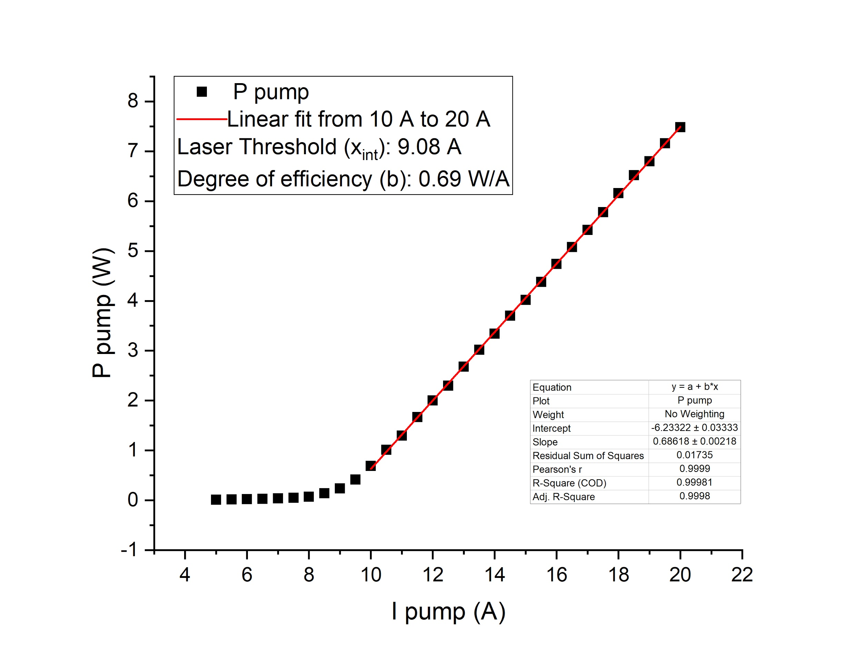

Fig 1: Shows the characteristic line of the laser diode. The output power of the diode is plotted as a function of the input current.

**5.3 Slope efficiency for the Nd-YLF crystal**

In this part of the experiment, the output power of the laser is plotted against the input power from the diode. The slope efficiency is the slope from this characteristic line. To calculate the laser threshold for the Nd:YLF crystal, a linear extrapolation is made to determine the intercept with the horizontal axis. This value represents the amount of input power required in order to observe lasing. See fig.2 for the plot and the data for the slope efficiency and laser threshold.



**5.4 Mode-locked operation of the Nd-YLF laser**

In this step the frequency generator of the the AOM (acoustooptical modulator) is turned on. The AOM is driven by an RF source that and creates a signal of V with a frequency MHz. This driving frequency produces a standing acoustical wave in a fused silica crystal fitted with a piezo-electric transducer. The observed oscilloscope output produced a wave of frequency on the order of nanoseconds however the frequency of the standing waves in the crystal is of order picoseconds. The oscilloscope does not have the resolution capability to observe the pertinent wave pattern. To do so would require fpga firmware that can resolve higher frequency signals.

**5.5 Autocorrelation function for the laser pulse**

For the next part of the practice the beam is splitted after it exits the resonator cavity into two perpendicular optical paths that are later put together and focused into a BBO crystal. This crystal shows a nonlinear behaviour for the incoming light which creates a new photon when two photons overlap within the crystal. Energy and momentum are conserved in this interaction and, thus, the new photon energy is the sum of the two original ones and the direction of emission is the such that the momentum is conserved. In this case the two incoming photons are infrared and the resulting photon will be visible green light. The resulting light intensity is then measured by a Si-avalanche-diode detector (DET 2).

For the measurement of the duration of the pulses, the difference between the optical paths is varied by displacing the mirror. Using the speed of light this difference in path length is converted into delay time between the two beams. In this way, the time duration of the pulses can be observed by its autocorrelation function as the two beams interfere with each other at the crystal. The resulting green light photons will only arrive at the detector when the pulse coincides in both paths. From this a relation between the FWHM (full width at half maximum) of the autocorrelation function and the duration of the pulses can be derived:

Figure 3 shows the data measured by the detector as function of the delay time. The FWHM is obtained from the gaussian fit of the main peak of the curve.



**5.6 Angular Harmonics**

In this part of the experiment the beam passes through a birefringent crystal before entering a intensity detector. The angle of the crystal can be varied to observe the interference of the main frequency of the laser with its first harmonic. Normally, in a dispersive media the relation :would not be true. But using a birefringent crystal, with two different refractive indexes for perpendicular directions of polarization, it is possible for a certain angle of the orientation of the crystal respective to the polarization plane of the wave and the harmonic for the two of them to match phases inside the crystal and interfere constructively.

Figure 4 shows the intensity measured at the detector after the beam passes through the crystal as a function of the angle of the crystal. The maximum of the constructive interference is observed at an angle of -0.02 rad.

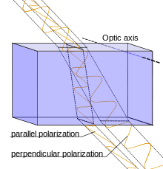

Fig. 4: Shows optical birefringence. The optical axis and direction of propagation define a plane. If the light is polarized parallel to the plane it is refracted by index of refraction . If the light is perpendicular to this plane the index of refraction is





The structure of the intensity as a function of the rotation angle of the crystal shows local maxima and minima near the base of the main peak corresponding to those of a function. From the local maxima and minima near the base of the main peak, we can know for which angles the argument of the function is or . See table 1. below.

|  |  |
| --- | --- |
| **Maxima** | **Minima** |
| -0.21 | -0.18 |
| 0.18 | 0.15 |
| -0.34 | -0.30 |
| 0.32 | 0.27 |

Table 1: The max and min values of for min and max intensity values

To calculate the path length for light in the crystal before passing through the crystal can be found from eq. 1, see below.

(1)

In this equation d is the width of the crystal, n is the index of refraction of air is the index of refraction of the crystal. But n’ is not constant, it depends on the angle of the incident light. It can be calculated using eq. 2:

+- (2)

The results are tabulated below in table. 2 for the values of theta max and theta min from table 1.

|  |  |  |
| --- | --- | --- |
|  |  |  |
| -0,21 | 1,65 | 4,03 |
| 0,18 | 1,65 | 4,02 |
| -0,34 | 1,64 | 4,09 |
| 0,32 | 1,64 | 4,08 |
| -0,18 | 1,65 | 4,02 |
| 0,15 | 1,65 | 4,02 |
| -0,30 | 1,64 | 4,07 |
| 0,27 | 1,64 | 4,05 |

Table 2: Shows the index of refraction of the crystal (n’) for different values of and path length (

The intensity of the light inside the crystal can be shown to be proportional to a function as

) (3)

Where is the incident intensity and is called the wave-vector mismatching and is given by eq. 4.

(4)

Where is the magnitude of the wave vector at a given frequency of electromagnetic radiation.

So by setting the argument of the sinc function in eq. 3 for the maximum and minimum values of intensity corresponds to for the the max intensity values and for the minimum intensity values, the pertaining values of are calculated and presented in table 3.

|  |  |  |
| --- | --- | --- |
|  |  | (rad) |
| 4,03 | 0,389 | -0,21 |
| 4,02 | 0,390 | 0,18 |
| 4,09 | 0,385 | -0,34 |
| 4,08 | 0,385 | 0,32 |
| 4,02 | 0,781 | -0,18 |
| 4,02 | 0,782 | 0,15 |
| 4,07 | 0,773 | -0,3 |
| 4,05 | 0,775 | 0,27 |

Table 3.: Shows the values of the wave-vector mismatching for corresponding values of for min and max intensity values and path length of radiation in the crystal for that angle

**5.7 Measurements with the spectrometer**

For the calibration of the spectrometer, a He-Ne laser is used to determine the spectral spacing of two pixels. While representing the intensity over pixel number, a very narrow peak is observed with a 3 pixel width. Two measurements for the He-Ne laser are performed, one with the spectrometer adjusted at 633 nm and another with an offset of 10 nm (643 nm).

The spectral spacing of the two pixels can be determined using a linear relation between wavelength and pixel number:

To determine which wavelength corresponds to a specific pixel number, a conversion formula is needed:

=

With Pixel as the reference value to pixel number and #Peak1 as the pixel number for the maximum intensity for the He-Ne spectrum adjusted at the set wavelength of 633 nm.

Three different spectra are measured for 3 different currents: at 7 A, 8 A and 8.2 A respectively. At 7 A, a broad spectrum is observed as we are under the laser threshold (9.08 A as calculated from 5.1) of the laser diode so there is no lasing yet.



At 8 A, a narrower peak is seen so we could assume that the lasing is starting to be produced. However, we are not yet over the laser threshold but in a transition region.

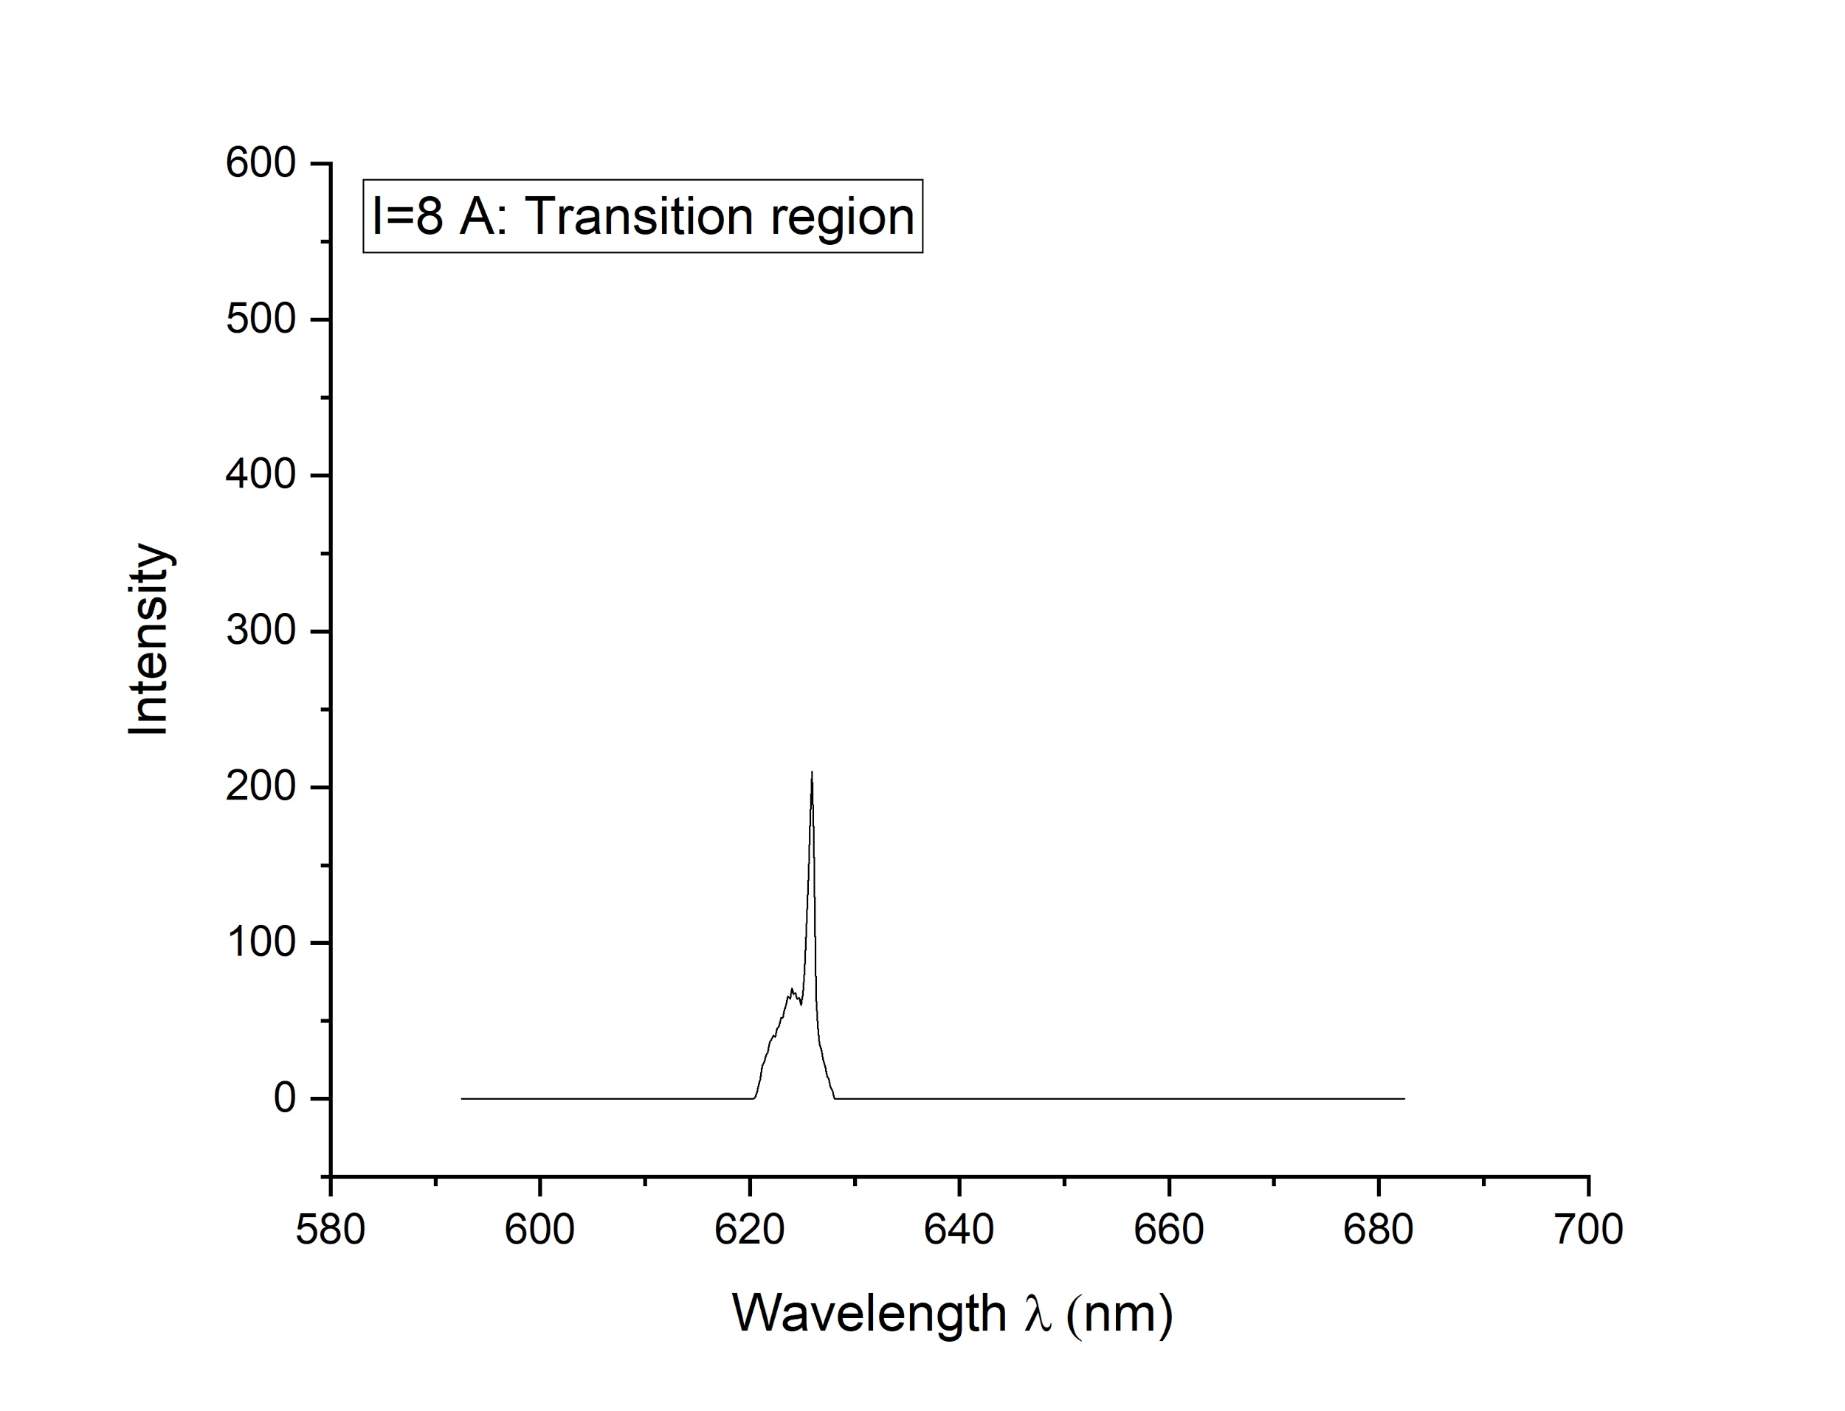

Fig 7 : Laser diode spectrum at I = 8 A

For the last measured spectrum, the current intensity is increased just 0.2 A and two narrow peaks are observed this time. This indicates that the pump laser is very sensitive to current changes inside the transition region. This will continue to happen as much as we are under the laser threshold current (9.08 A).

